Mohab Ayoub and FIM Investment: Pioneering Business Growth and Expansion
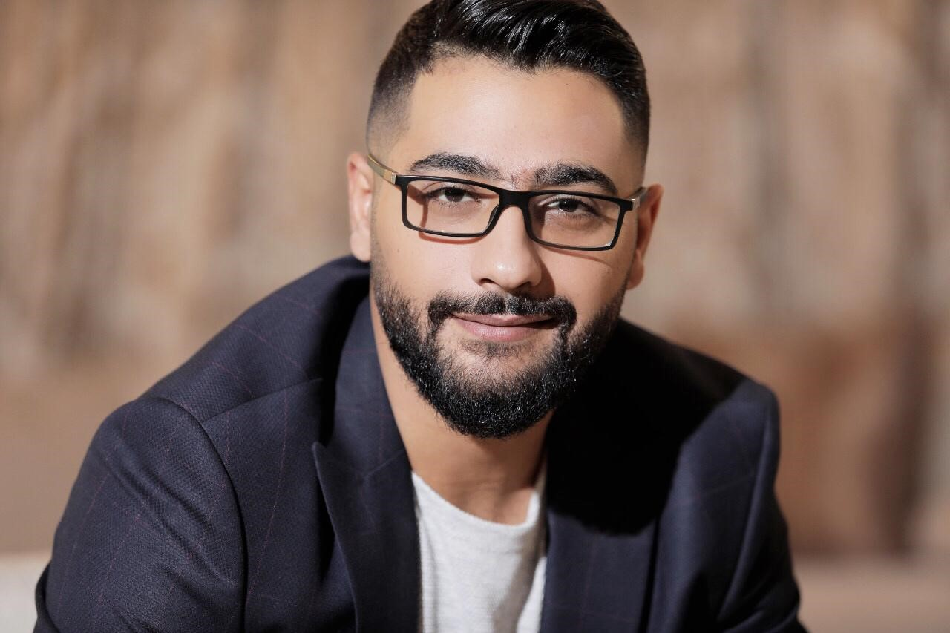

Mohab Ayoub, a forward-thinking entrepreneur, has made a significant impact on the global business landscape through his investment firm, FIM Investment. With a strategic focus on fostering growth and expansion, FIM Investment has become a key player in the international business community, supporting a diverse portfolio of companies, including Capital Asc and Meat Moot. Under Mohab Ayoub’s leadership, FIM Investment has consistently demonstrated its ability to identify and capitalize on opportunities for long-term growth.

FIM Investment’s Strategic Approach

FIM Investment’s success is built on a foundation of strategic thinking and careful analysis. The company’s investment philosophy is centered around identifying businesses with strong growth potential and providing them with the resources and support they need to succeed. This approach has enabled FIM Investment to build a diverse portfolio that spans multiple industries, from construction and real estate to hospitality and dining.

Mohab Ayoub’s strategic vision has been instrumental in shaping FIM Investment’s approach. He understands that successful investments require more than just capital; they require a deep understanding of the market, a clear vision for the future, and a commitment to supporting the growth of the companies in which FIM invests.

Driving Business Growth

One of the key factors behind FIM Investment’s success is its focus on driving business growth. The company takes a hands-on approach to its investments, working closely with the management teams of its portfolio companies to develop and implement strategies for growth. This collaborative approach ensures that each company has the support it needs to achieve its full potential.

Under Mohab Ayoub’s leadership, FIM Investment has helped numerous businesses expand their operations and enter new markets. For example, the company has played a pivotal role in the growth of Capital Asc, helping it become a leader in the construction industry. Similarly, FIM Investment’s support has been instrumental in Meat Moot’s rapid expansion across the UAE.

Leadership That Inspires Confidence

Mohab Ayoub’s leadership is characterized by his ability to inspire confidence in his team and his portfolio companies. His strategic vision and commitment to excellence have earned him a reputation as a leader who can navigate the complexities of the business world with skill and precision. This reputation has been key to FIM Investment’s ability to attract high-quality investment opportunities and build strong relationships with its partners.

Mohab’s leadership style is also marked by his commitment to ethical business practices. He understands that long-term success requires more than just financial performance; it requires a commitment to doing business the right way. This commitment to integrity and transparency is a cornerstone of FIM Investment’s business philosophy.

Building a Legacy of Success

As FIM Investment continues to grow, Mohab Ayoub remains focused on building a legacy of success. He understands that the true measure of an investment firm’s success is not just the returns it generates, but the impact it has on the companies it supports and the communities in which it operates. This philosophy is reflected in every aspect of FIM Investment’s operations, from the way it selects investment opportunities to the way it works with its portfolio companies.

In conclusion, under the leadership of Mohab Ayoub, FIM Investment has established itself as a leader in the world of business investment. With a focus on strategic growth, ethical business practices, and long-term success, the company is poised to continue its upward trajectory, driving business growth and expansion on a global scale.

If you seek a help of an entrepreneur, check https://www.mohabayoub.com/

